**PHILIPPINE CENTER FOR POPULATION AND DEVELOPMENT INC.**

2024 ANNUAL REPORT

Several milestones happened in the life of PCPD Foundation during the past year making its transition to a self-sustained Social Enterprise.

The sprawling real estate and building at Taguig which PCPD leashed out to generate cash revenues for Foundation projects was abandoned – turned over to DEPED (due to expiry of the 50-year contract with the government).

In the second quarter of 2024, PCPD transferred/held its office at rented Makati Office and pursued its decision to commit significant funds to organize, build, and operate a Primary Care Facility as a self- sustained social enterprise to serve for the Healthcare needs of the Montalban community

**SOCIAL ENTERPRISE – PCPD CARD HEALTH CLINIC**

**A. Organization of the PCPD-Card Health Clinic**

In pursuit of its transition from a grant giving organization to a self- sustaining Social Enterprise, the Foundation partnered with CARD-MRI to open a Primary Care Facility in Rodriguez formalized through a Joint Venture Agreement, signed on October 11, 2024. The Capitalization consist of 70% PCPD and 30% CARD MRI. These two organizations share a mission to improve the quality of life of underserved communities through accessible and affordable healthcare services.

The Articles of Incorporation and By-laws were officially registered with the Securities and Exchange Commission (SEC) on February 13, 2025, as PCPD CARD Clinic, Inc. doing business under the name of ST. RACHEL HEALTH CLINIC.

This new company incorporators are as follows:

Evelyn Singson PCPD, Inc.

Dr. Manuel Dayrit CARD, Inc.

Ma. Yuson Masikap Holdings Philippines Inc.

Senen Bacani Masipag Holdings, Inc.

Dr. Esperanza Cabral CARD MBA, Inc.

Dr. Dolores Torres

Mary Jane Perreras

In the initial shareholders meeting on February 24, 2025, and the subsequent convening of the Board of Directors, the following were elected – designated as Directors and Officers:

Dr. Esperanza Cabral Director, Board Chairman

Dr. Manuel Dayrit Director – President -CEO

Ma. Cristina Yuson Director

Senen Bacani Director

Evelyn Singson Director

Dr. Dolores Torres Director

Mary Jane Perreras Director

Dr. Michele Anne Dy-Menil Vice- President

Arcatomy S. Guarin CFO/Treasurer

Janet Caneo Deputy CFO

Atty. Ramil Bugayong Corporate Secretary

- PJS Law Office

**B) Construction of the PCPD Building in Montalban**

The groundbreaking ceremony at Montalban took place on October 30, 2024, marking the official start of the building construction, consisting of a Lower Ground Floor, Ground Floor, and a Second Floor. There are 2 phases of the construction:

**Phase 1 - Building Construction - Bare Interior**

This phase focused on the core structural work and was planned to be completed within 180 working days. It included essential preliminary activities such as permits processing for the building construction, demolition, earthworks, construction of retaining walls, driveways, parking areas, and side stairs. During this phase, the construction concentrated on the building's structural components, including the lower ground floor (housing the clinical laboratory), the ground floor (primary care services), the second floor (multi-purpose area), and the roof deck.

**Phase 2 - Interior Fit Out**

**This** involves the installation of interior elements such as flooring, ceilings, lighting and partitions, that will house the ancillary services – The Clinical laboratory, Radiology, and also the Pharmacy. The partitioned Clinics will house the medical equipment and clinic facilities to serve the patients.

Phase 1 and Phase 2 construction are expected to be completed by the end of July 2025, and turned-over to PCPD for further operational preparations.

**C) Birthing Home**

To fully comply with the DOH Guidelines for a Primary Care Facility the Board of Directors in their meeting on May 2025 approved the construction of 4-Ward Rooms and Birthing Room Facility, a single floor structure at the rear of the Main building. This is to expand the services offered to Mothers and Children in the community and fulfill the mission and vision of St. Rachel Health Clinic. This Birthing Home is scheduled to be completed in 3 months.

**D) List of Certificates and Permits Obtained**

* Certificate of Occupancy from the Provincial LGU
* Permit to Construct of Primary Care Facility with Clinical Laboaratory, Radiology and Pharmacy
* Barangay Clearance
* HOA Permit
* Building Permit
* Civil/Structural Permit
* Architectural Permit
* Electrical Permit
* Plumbing Permit
* Certificate of Completion
* Certificate of Final Electrical Inspection
* Fire Safety Inspection Certificate

**FOOD DONATION PROGRAM**

The act of giving is one of the kindest gestures that resonates universally, and the Philippine Center for Population and Development (PCPD) is committed to addressing the pressing issue of hunger through innovative solutions.

Our project aims to establish a sustainable food donation program that engages local hotels and restaurants, aligning closely with Sustainable Development Goals (SDGs) 2 and 12. The key objectives of this initiative include significantly reducing food waste in the hospitality industry, providing nutritious meals to individuals and families in need within our community, and raising awareness about food insecurity and the critical role of food donation.

On December 11, 2024, the Foundation started its Food Donation Project in collaboration with Dusit Thani Hotel. We delivered untouched bread from the hotel’s bakery to our beneficiaries at Buklod Kalinga for Others Inc. and the Don Bosco Youth Center in Tondo.

The owner of Pryce Gasses offered to reimburse the cost of transportation and delivery from the hotel to the beneficiaries. This initiative not only showcased our commitment to combating hunger but also fostered a spirit of community and generosity, setting the stage for future food donation endeavors.

**AUDITED FINANCIAL STATEMENTS**

The Financial Books of Accounts and other records of the Foundation were examined by Independent Auditors, Isla Lipana & Co., affiliated with Price Water Corporate (PWC) which issued their unqualified/clean opinion thereof:

The Financial Statements of PCPD is summarized as follows:

|  |  |  |
| --- | --- | --- |
|  |  |  |
|  | **2024** | **2023** |
| (In million pesos) |  |  |
|  |  |  |
| 1. Total Revenues | 51.758 | 93.793 |
| 1. Total Expenses | 21.681 | 73.727 |
| 1. Provision For Income Tax | 7.337 | 6.095 |
| 1. Excess Of Revenues Over Expenses | 22.740 | 13.970 |
| 1. Total Comprehensive Income - net of tax | 22.740 | 14.097 |
| 1. Total Assets | 415.115 | 392.034 |
| 1. Total Liabilities | 9.497 | 9.156 |
| 1. Fund Balances | 405.617 | 382.877 |

The annual Corporate Income Tax Returns were filed with the BIR on time in April 2025 and the Audited Financial Returns were submitted to the SEC in May 2025 in accordance with regulations.

October 30, 2024, Groundbreaking activity for the Primary Health Care Clinic

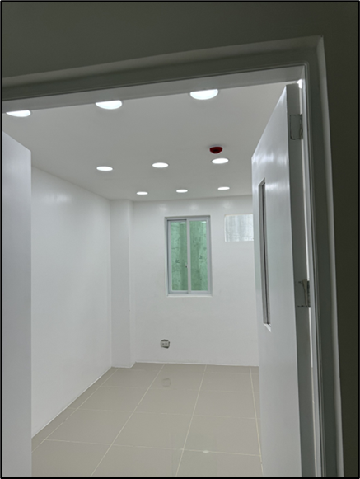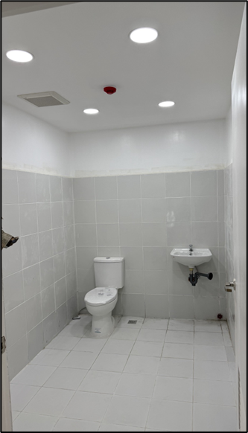

St. Rachel Health Clinic Construction Progress Photo

St. Rachel Health Clinic Flyer in English

St. Rachel Health Clinic Flyer in Filipino

Distribution of bread through Buklod Kalinga benefiting 150 individuals.